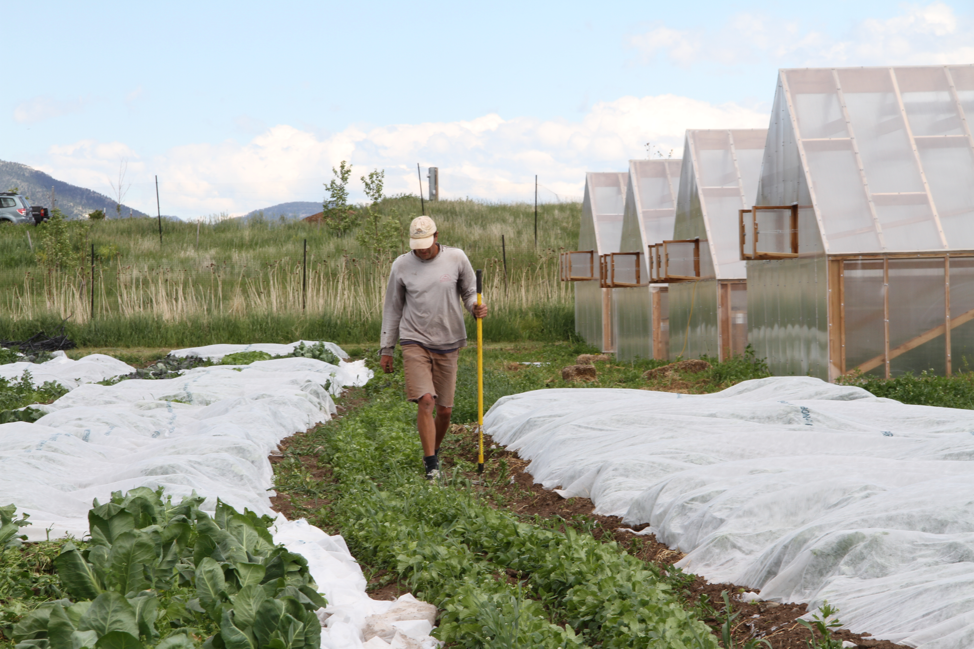

**Three Hearts Farm 2015 CSA Registration Form**

Mail this form with your payment to:

**Three Hearts Farm, 2111 Love Lane, Bozeman, MT 59718**

Checks can be made out to ***Three Hearts Farm*** and upon receipt of payment we will send you a confirmation email.

**CSA Options**

**( ) Full Season $500**

**Pick up Options**

**( ) Hands-on Option-**pick up your share at the farm

**( ) Market Option-**pick up your share in town

**Payment Plan**

Your share is reserved on receipt of this form with your payment. Shares are available on a first come, first serve basis. Cancellations prior to May 1st will be refunded minus 10% of the share cost. Checks will not be deposited until the date written on the check. We want everyone to be able to be able to access the freshest, healthiest produce available so if none of these payment plans work for you contact us and we will work something out.

**( ) One time payment-** enclose check for full amount with today’s date

**( ) Two payments**- enclose two checks of equal amounts, one dated today, one dated May 1st

**( ) Three payments-** enclose three checks of equal amounts, one dated today, one dated April 1st, and one dated May 1st

**Shareholder Information**

**Name(include names of all members if sharing a subscription)**

**Address**

**Phone Email**

**Have you been a CSA Member before? Yes ( ) No ( )**

**If yes, which CSA farm?**

**How did you hear about Three Hearts Farm?**